**Name: SHAMJAD MAZOOD NAZER**

**Roll No: 36**

**Batch: B**

**Date: 21-04-2022**

**NETWORKING & SYSTEM ADMINISTRATION LAB**

**Experiment No.: 7**

**Aim**

Familirization of linux commands

**Procedure**

1. read : to read the contents of a line to a variable.

$read <variable_name>

$echo $<variable_name>

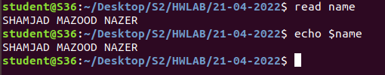

1. locate : find files by name

$locate <file_name>



1. find : search for files in a directory hierarchy.

$find <file_name>

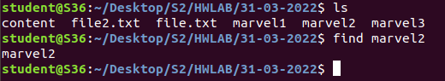

[option]

-i : returns file both uppercase/lowercase (Omit Case Sensitive)

$find -i <file_name>



1. grep : print lines matching a pattern

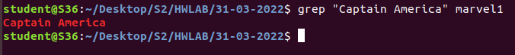

[OPTION]

-i : ignore case distinctions



-v : invert-match; select non-matching lines

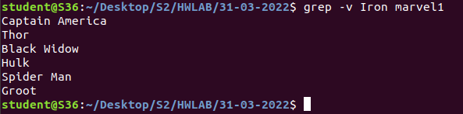

-A1 : print NUM lines of trailing context



-B1 : print NUM lines of leading context



-C1 : print NUM lines of output context

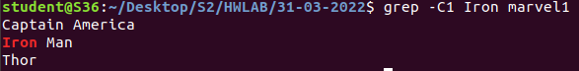

1. df : report file system disk space usage

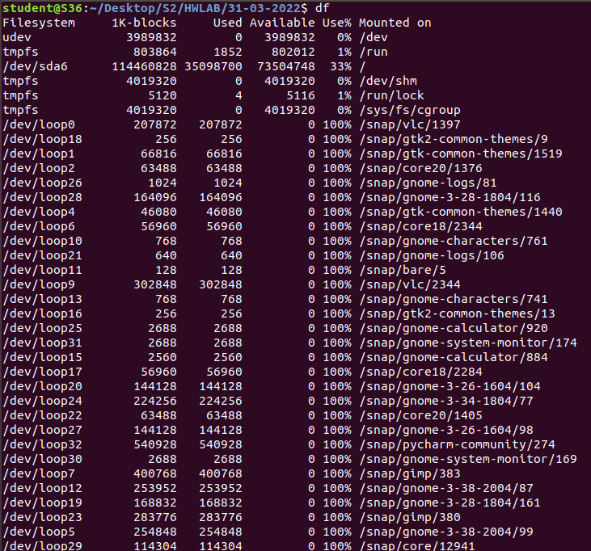

[OPTION]

-m : The SIZE argument is an integer and optional unit (example: 10K is 10*1024).

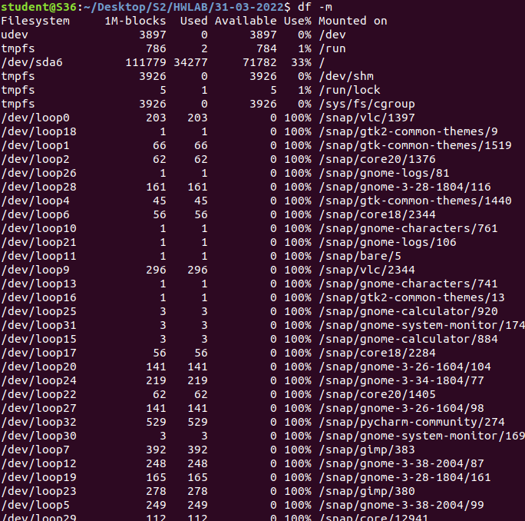

1. du : estimate file space usage

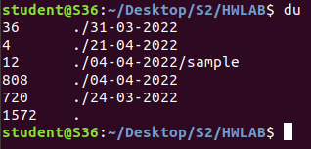

1. wc : print newline, word, and byte counts for each file



[OPTION]

-c : print the byte counts



-m : print the character counts



-l : print the newline counts



-w : print the word counts



**Output Screenshot**